

|  |
| --- |
| Apparel and Footwear |
| **Materials List Management** |
| Argentis Consulting |



**www.argentisconsulting.com**

Styles and Raw Materials generation

Apparel Styles

Styles are created as finished products in SAP with information about colors, scales and sizes as well. SKUs are generated from this combination.

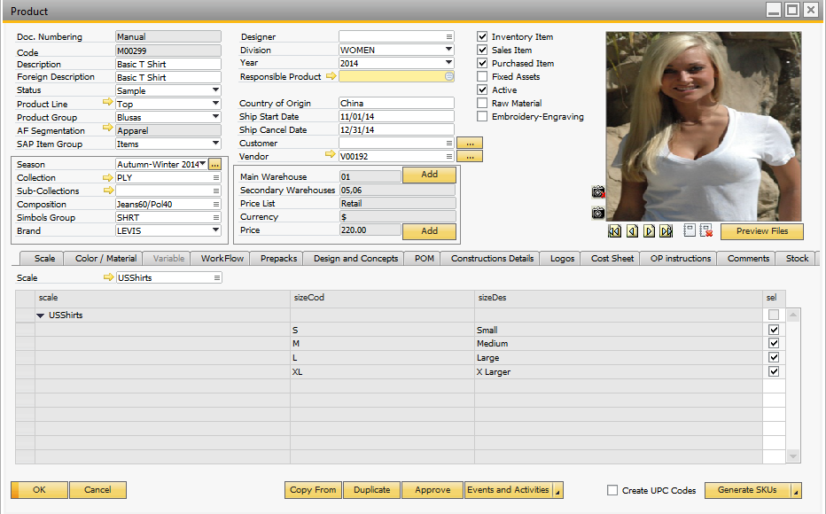

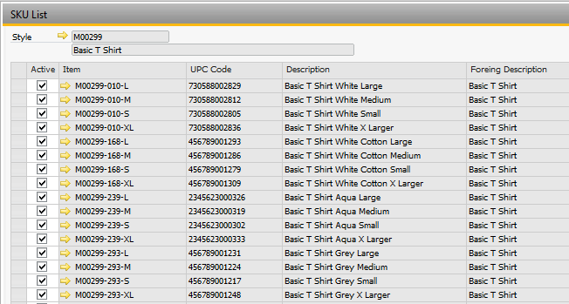

Materials

Materials are components for either local or outsourced production. The materials that have information about colors and/or size scales should be created in the Product Data Management screen (Apparel and Footwear > Master Data > Product Data Management).

In order to generate the items to be used as raw materials you should select the option “Raw Material”.

* Fabrics. Fabrics have a segmentation with information about colors.

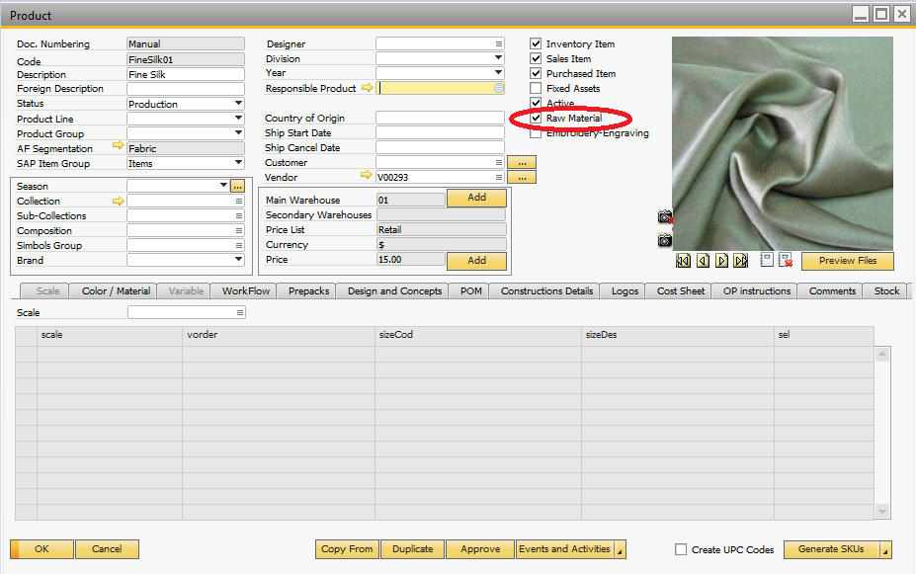

Next we generate the SKUs

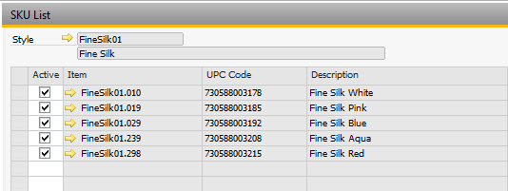

* Tags. Tags have a segmentation with information about colors and size scales.

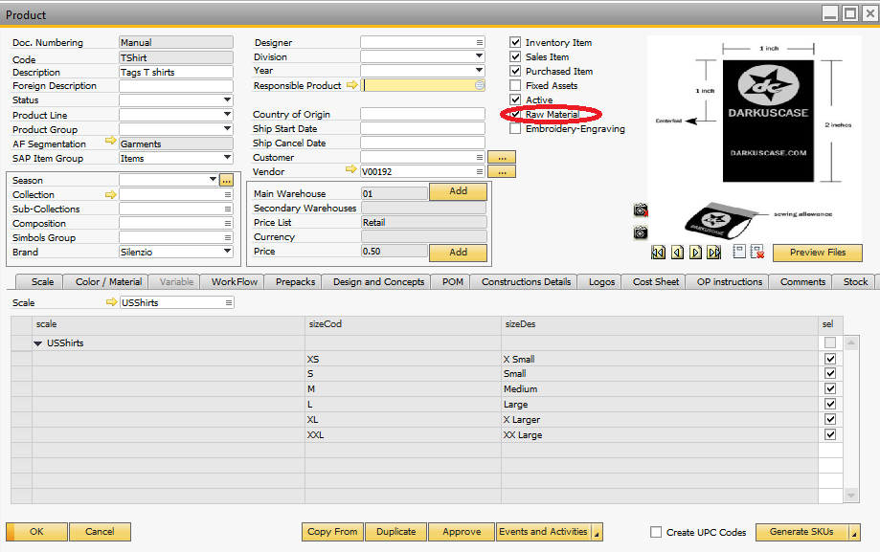

Next we generate the SKUs

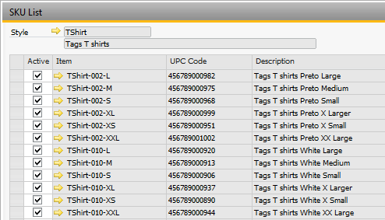

Raw materials that do not have segmentation information about colors or sizes must be created as an item in SAP by going to Inventory > Item Master Data.

Production Operations creation

Operations

Operations are applied to the production process in order to create a semi-finished (saw) or finished (packing or quality) product. For this, an operation item is generated in SAP Business One.

Go to Inventory -> Item Master Data.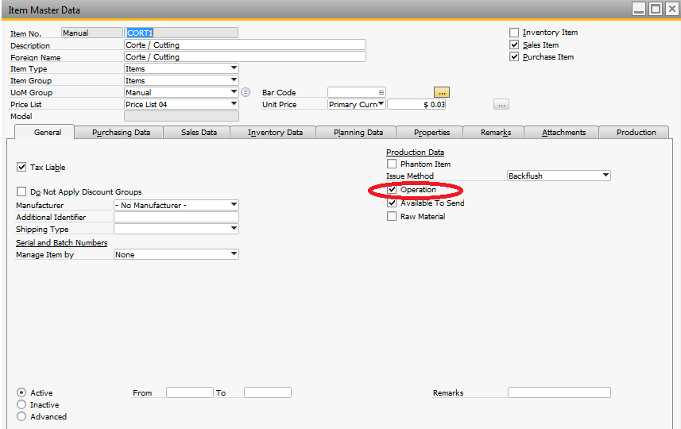

Operations Template

Once the operations have been created, proceed to create the Templates. The objective is:

1. Create materials lists and labor (Materials Sheet and Technical Sheet)
2. In the costs stage define the total costs for the operations.
3. In the production stage, get the sequencing and control the production process.

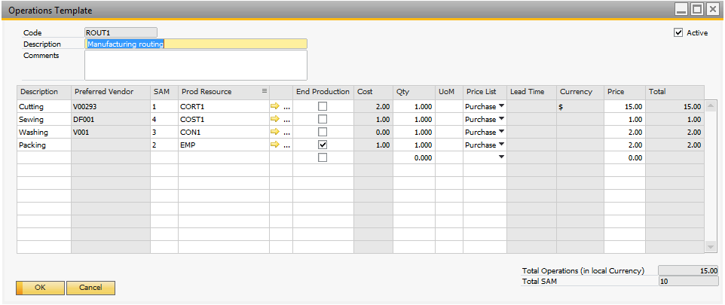

Go to Administration 🡪 Setup 🡪 Apparel and Footwear 🡪 Setup 🡪 Costing 🡪 Operations Template.

Costing Templates process

Costing Sheet

Different Cost Sheets can be defined in the Style, including different values in order to study, compare and decide the components and operations with their costs. Materials and operations will be used in next steps for BOM creation.

Selecting the Materials from the item master data of SAP, materials can be included in the cost sheet with quantities, cost price, currency, vendors, in order to get the total cost of materials used for the production process.

Now it is possible to select the size automatically of a semi-finished or raw materials based on the size of its parent product. The BOM wizard also proposes the color and fabric consumptions based on parent attributes.

From the Template we should select the option Cost Sheet🡪 Add Cost Sheet.

Setup the materials: Fabrics, soles, zippers, etc.

Add the production operation template and, if necessary, add the indirect costs as well through indirect cost schemas.

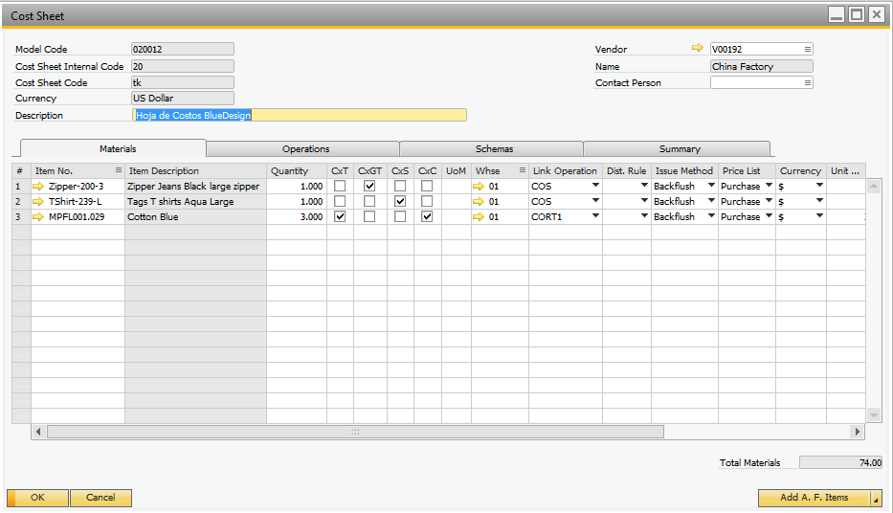

There are 4 options in the Cost Sheet:

* CxT= Check to apply consumption by % defined in the scale. When the fabric consumption varies for each scale.
* CxGT = Check to combine sizes groups. For example, Sole size 38 for boot size 37.
* CxS = Check to combine the size of the raw material with the size of the finished product. If the size scale matches, for example, Sole 37 to Boot 37.
* CxC= Check to combine the color of the raw material with the color of the finished product. If the color matches, for example, Black lether with Black Boot.

If NO match found, the material that we use is placed on the cost sheet.

CxGT – Size Groups

Let’s say that the same Zipper Small for Tshirts sizes Small, Medium and Large.

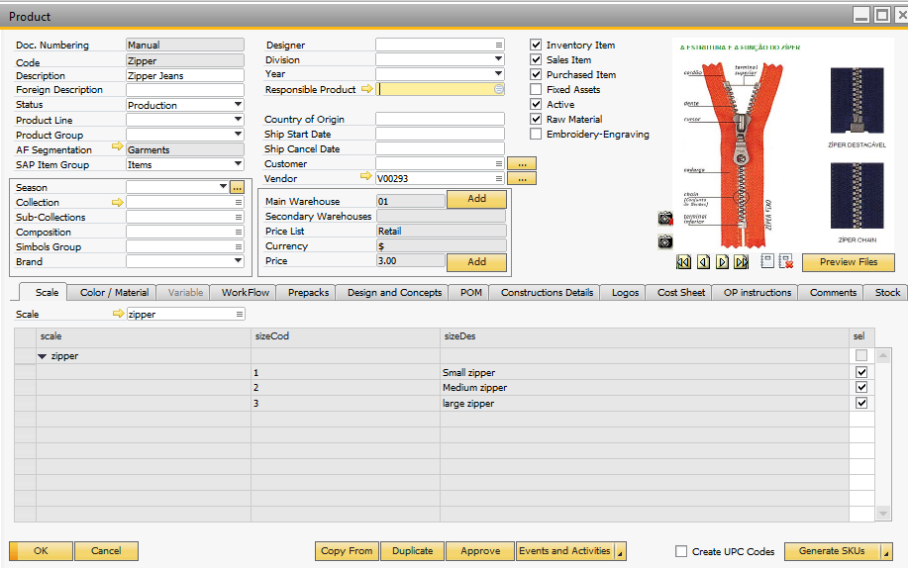

Size groups are defined in Administration 🡪 Setup 🡪 Apparel and Footwear 🡪 Inventory 🡪 Size Groups.

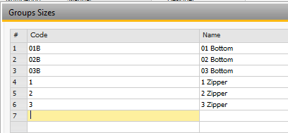

After that, in the size scale for the zipper is defined the Size Group for the size matching.

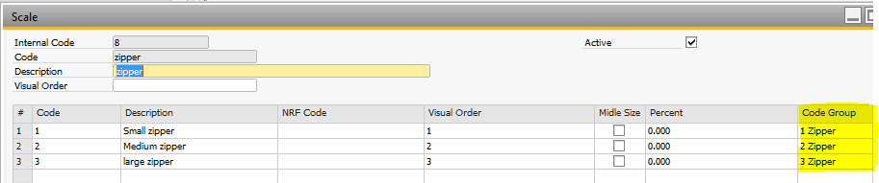

The same match is made for the Tshits scale.

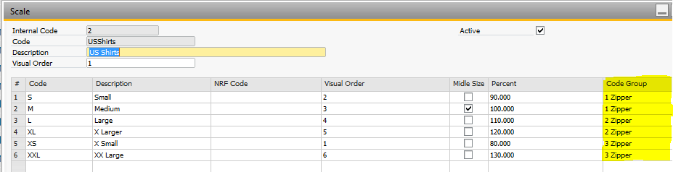

Raw Materials creation process

Once the cost sheet for the finished product has been created, from the same product screen and in the option Cost Sheet, pick the option **BOM WIZARD.**

The system proposes for each combination created in the model, a list of materials based in the materials included in the cost sheet.

If necessary, it is possible to make manual modifications to the list of materials. After running the BOM WIZARD, select the option **Create/Update BOM**.

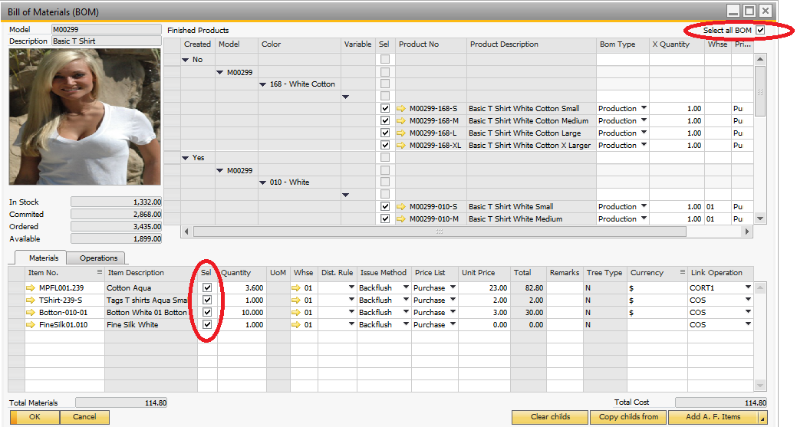

With the check box in the upper right corner of the screen, pick the items to be modified.

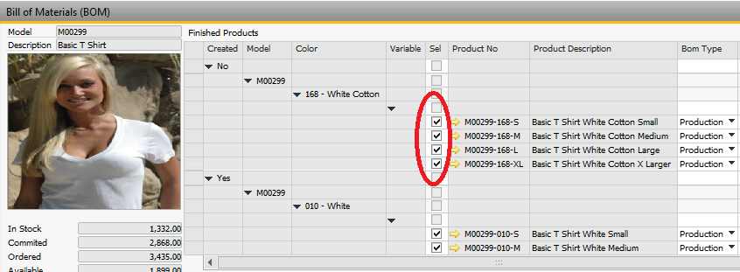

With the check box in the middle, pick the raw material to be modified.

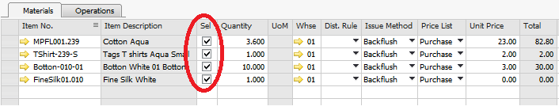



**www.argentisconsulting.com**

**Argentis Consulting** is dedicated to the development, distribution and support of recognized certified solutions for SAP Business One, as an SSP (Software Solution Provider) with a Gold Partner status.

|  |  |
| --- | --- |
| **USA**  9744 NW 45th Lane  Doral, FL 33178  info@argentisconsulting.com | **ARGENTINA**  Ávila y Zarate 2048  Cerro de la Rosas, Córdoba,  CP 5009  Córdoba - Argentina  info@argentisconsulting.com |
| **CARIBEAN**  City View Plaza – Suite 301  48 Road 165  Guaynabo, PR. 00968  Puerto Rico  caribe@argentisconsulting.com | **SPAIN**  C/ Juan Bravo N° 3 A 28006  Phone: (+34) 91 123 7263  Madrid - Spain  info@argentisconsulting.com |

**Contact Information**